1 COGNITIVE-AFFECTIVE-BEHAVIORAL THERAPY
A (CABT) APPROACH TO THERAPY
CABT is an Approach to Emotional Intelligence (EI)

All therapeutic approaches operate in one of three areas: cognitive, affective, and behavioral. Since all three approaches work to some extent with different individuals, there must be three types of humans or one type of human whose behavior stems from one or a combination of these three areas. CABT is an approach that combines the three basic areas of human behavioral change.

CABT is based on three concepts:
- What you think determines what you feel.
- What you feel allows you to choose how to behave.
- Your brain has two functioning operating systems:
a) the left brain, which thinks logically and systematically, and
b) the right brain, which thinks in pictures and flashbacks.


This concept is not new; in 700 BC, Psalms 23:7 says, “As a man thinks it in his heart, so is he.” Then, in 35 A.D., a Roman slave wrote, “Men are disturbed not by things but by the view they take of them.” Epictetus. Then David Burns, in his book FEELING GOOD, wrote, “You feel the way you do right now because of the thoughts you are thinking at this moment.”

Now, here comes the surprise. Everyone thinks! “But, you say, that is no surprise, everyone knows they think.” Look at your own thoughts that keep you awake at night. If you are the one who chooses to think these thoughts, then what is the purpose of choosing to stay awake all night?

The idea that you think and can think about anything you choose to think or not think about anything you choose not to think, has been known and practiced for thousands of years.
“You have the power over your mind—not outside events!
Realize this, and you will find strength.”
~ Marcus Aurelius, 121 A.D. Roman Emperor

Melissa feels overwhelmed. Her feelings are caused by what she thinks, which is why she feels overwhelmed.
Steve feels anxious and uptight. Steve does not know it, but his anxiety is the result of what he is thinking.

Third Concept of CABT
Your head contains two brains or two types of operating systems. For convenience, we say one side generates your IQ, and the other generates your EQ. Your IQ + EQ = Emotional Intelligence (EI).

Your brain processes information in two very different ways! One side is logical,
rational, and deductive. This is the cognitive (left side) of your brain and is measured by IQ tests.

The other side (right side) processes information emotionally. Its source of information is memory and pictures. For example, you visit a beautiful ocean with fluffy white clouds. And you listen to the sound of waves breaking on the shore, and your body relaxes. Whenever you “see” that memory, your body relaxes like you were still at the ocean. Seeing a memory from the past is sometimes called a “flashback.”

On the other hand, if you are involved in a traumatic incident in which someone dies, you experience anxiety and fear. Whenever you bring that memory up (flashback), you will experience the same feelings as if it were happening right now. Both examples are of Emotional Intelligence (EI).

Emotional Intelligence — the skill of knowing what you feel and then choosing to feel something different by "seeing” a different picture. This ability is critical to your work and life success. You can increase your EQ by learning and practicing Awareness.

You were born able to recognize when you are experiencing an emotion. When you were born, you would readily tell others when you were angry, happy, or sad, and you could express these feelings at will. As you grew older, you likely learned how to disregard your emotions, hide them as often as possible, and rationalize why you feel the way you do to deal with the situation in “socially acceptable ways.”

No matter what people tell you about the evils of emotions, such as: “You should not feel that way,” “Nice girls do not get angry,” “Pretty is as pretty does,” and “Anger is a sin.”, the truth is that your emotions are not good or bad, right or wrong. They just are.

“There is nothing either good or bad, but thinking makes it so.”
~ Shakespeare, in “Hamlet”

What you choose to do with your feelings (and behaviors) can get you into trouble. No one has been put in prison for being angry. However, expressing your anger can certainly bring the police to your door.

If you don’t recognize your feelings, you cannot fully understand what motivates your actions. This lack of awareness limits your ability to choose how you want to feel and act, negatively impacting your relationships, job performance, and overall happiness. Your upbringing likely stunted the development of your emotional intelligence.

Emotional Quotient — EQ also increases your understanding of others: what motivates them, how they work, how to work cooperatively with them, and how to inspire them to reach their potential. Are you lacking or forgetting to access your Emotional Intelligence?
See the list below for how low EQ can affect you:
__ You quickly blame other people for your problems or errors.
__ You don’t take feedback well, get defensive or shut down when comments are offered, and hurt your feelings.
__ You get impatient and frustrated when you think others don’t understand or appreciate what you are saying.
__ You don’t forgive people easily; sometimes, you choose never to forgive.
__ You are quick to judge people for who they are, what they wear, what they say, and/or what they do based on what you think is correct and best.
__ You are very selective about whom you will spend time with and share your thoughts with because other people do not have your beliefs or values.
__ You give your opinions early in a conversation and hold on to them no matter what anyone says because you see things in black and white with very little gray.
__ You constantly declare that you don’t care if people like you. This is based on your fear of rejection. “I reject other people before they can reject me.”
__ You think emotions are overrated, and it doesn’t matter what other people feel.
__ You quickly challenge new ideas that might impact your work, family, and relationships.
~ Robert H. Smith, University of Maryland

Now, look at the opposite, the behaviors that you will demonstrate when you have Emotional Intelligence. The behaviors that demonstrate EI include:
- Resilience and flexibility.
- Listening and accepting, because you see acceptance not as approval but accepting the person where they are until they can be someplace else.
- Forgiving, by no longer judging the other person’s behavior. There would be nothing to forgive unless you first judged the person.
- Taking personal responsibility.
- You seek other points of view. You are comfortable with your beliefs and are not threatened by other’s beliefs.
- You understand, accept, and can explain your emotional reactions because you understand the thoughts that are creating your feelings.
- Staying calm under pressure because you believe you can handle whatever happens.
- You use emotions appropriately to both inspire and make others feel comfortable.
- You admit and learn from mistakes. You believe that mistakes are just stepping stones and that nothing is a mistake if you learn from it.
- Take feedback easily by understanding that positive or negative feedback is not about you. It is about the other person’s thoughts, values, and beliefs.
- Your body language matches your words.
- Your behavior matches your words.

Here is the formula that you use to get to your behaviors:
- Something Happens à
- You Put a Meaning to It à
- You Feel(s) à
- Consciously or Unconsciously, You Choose Your Behaviors from the Feelings You Are Experiencing.
The following is a powerful exercise you can do to increase your emotional intelligence.

Let me say it a different way. Look at the chart below. Notice that your behavior is based on your feelings, which are based on your cognitive thoughts and emotional pictures. Something is said or happens to you or around you (EVENT) à you put a MEANING(s) to the event à FEELING(s) result, from which consciously or unconsciously you choose à your BEHAVIORS.

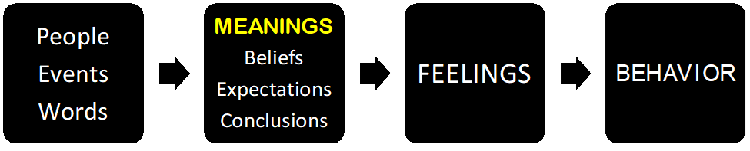
Depending on which of the three areas you are most aware such as “I am aware that I am feeling angry.” Go backward now to the meanings and figure out what you are thinking that is creating the feelings of anger. . . . “She just used and took advantage of me.” Now that I know what I am thinking, what else could I think? “She must feel very powerless and need to put me down.”

What flashback triggered you? (One, something similar happened in your past.) What are you experiencing right now? What would you like to get from the situation, such as respect, appreciation, or control? How could you respond to someone feeling powerless so that you get a different response?

All therapeutic approaches use one or a combination of Cognitive, Behavioral, and Feeling (Affective) approaches. Any one of these approaches works to help the therapist to help the client achieve the changes they are looking for. However, unless there is a permanent change in the client’s feelings, their behavior will not permanently change.

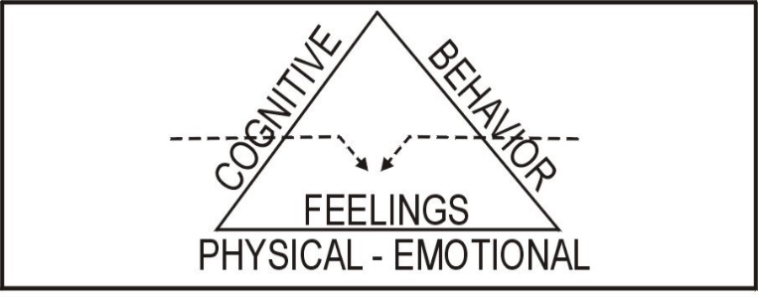

If you go to a CABT therapist, they will consider the two crucial points.
First, on what side of the brain do your issues stem? Cognitive or Affective, or a combination. (Is the client having flashbacks that are triggering the problems? Or are the client’s issues stemming from faulty or contradictory belief systems?)

Second, for therapists, I suggest you list all the intervention techniques you use with your clients and separate them into Cognitive, Affective, and Behavioral categories. Now, depending on where you see your client’s issues stemming, you will have an intervention. Use the following chart as a place to get started.

PRESENTING PROBLEM | Approach: Cognitive, Affective, Behavioral | INTERVENTION TECHNIQUE
Child --- divorcing parents | Cognitive | Mutual Storytelling & play therapy
Anger issues | Cognitive & Affective | CBT and role-playing
Anxiety issues | Cognitive, Affective, Behavioral | Doing what you are afraid to do, and Cognitive
Obsessive-compulsive disorder | Cognitive & behavioral | Enter your interventions
Guilt | Cognitive | Enter your interventions

If you are dissatisfied with your therapy, either the therapy that you are receiving or the therapy that you are providing, then CABT may be just what you’re looking for. Consider this analogy: you buy a brand-new car. It’s your car, and you can do anything with it. You decide you want a soft ride so that you will keep 10 pounds of air in the tires, and you don’t like to deal with messy oil, so you will never change the oil in the car. Will that car run?

Of course, it will run! But will it give you long, dependable service? I don’t think so. Cars are designed to be operated in a certain way, and when you don’t operate your car the way it is designed to operate, you will have many problems, costing you a lot more money.

The same is true for humans. If you do not operate your mind and body as designed, you will have problems.

For more therapeutic interventions and information,
You can contact Myron Doc Downing, MSW, Ph.D. at:
Email: DocDowning103@gmail.com

